Computer Systems Lecture 1

Evolution of Computers

Early computers had their programs set up by plugging cables and settings switches. John von Neumann first proposed storing the program in the computers memory and all computers since then (~1945) have been stored-program machines.

Since then the only real changes have been the number of transistors in these machines and their speed progressing from vacuum tubes to discrete bipolar transistors to integrated circuits made with complementary metal-oxide semiconductor (CMOS) technology.

Moore’s Law

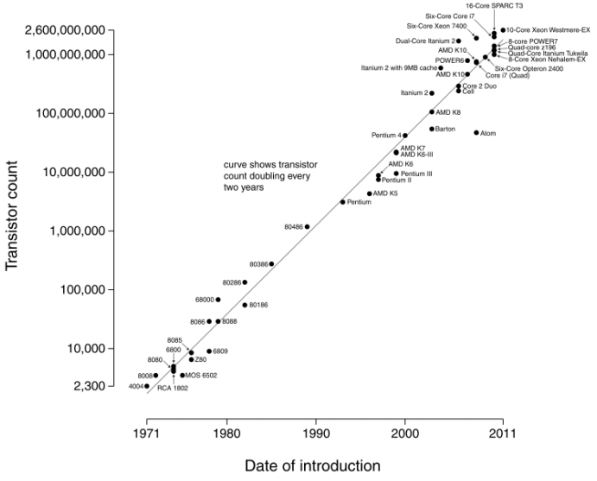The transistor counts in processors roughly double every 2 years.  
Types of Computer Systems

Servers

* Used for either a few large tasks (engineering apps) or many small tasks (Google)
* Fast processors, lots of memory
* Multi-user, multi-program

Personal computers

* Laptops, desktops
* Balance cost and processing power
* Few users, multi-program

Mobile devices

* Smart phones, tables
* Highly integrated (multiple processors, GPU, GPS ect…), low-power
* Single-user, multi-program

Embedded

* Task specific: sensing, control, media playback, etc…
* Low-cost, low-power
* Single program

Embedded Systems are by far the most common type of system with over 10,000,000,000 shipped per year.

Computer Components

Data path

* Performs actual operations on data

Control path

* Fetches instructions from program in memory
* Controls the flow of data through the data path

Memory

* Stores data and instructions

Input/Output

* Interfaces with other devices for getting/giving data

Both the data and control paths are part of the processor.

Modern Processors

Modern processors consist of multiple cores (all individual processors) with shared cache (very fast on-chip memory), a memory controller that interfaces with the storage and an interface for other chips and peripherals.

Modern Computer Systems

When we write applications, the computer can’t understand the code we write, it needs to be translated into machine code the computer can actually run. This is often done with a program called a compiler, compilers translate **high level languages**  into **machine language** or  **byte code**.

This then runs on the **Operating System** with mediates access to hardware resources (CPUT, Memory, I/O) and schedules applications.